Name: Sergio Gutierrez

bitbucket Repo: <https://bitbucket.org/SergioZGutierrez/homework/src/master/>

Exercise 9

This is the folder containing my apps, and java files:

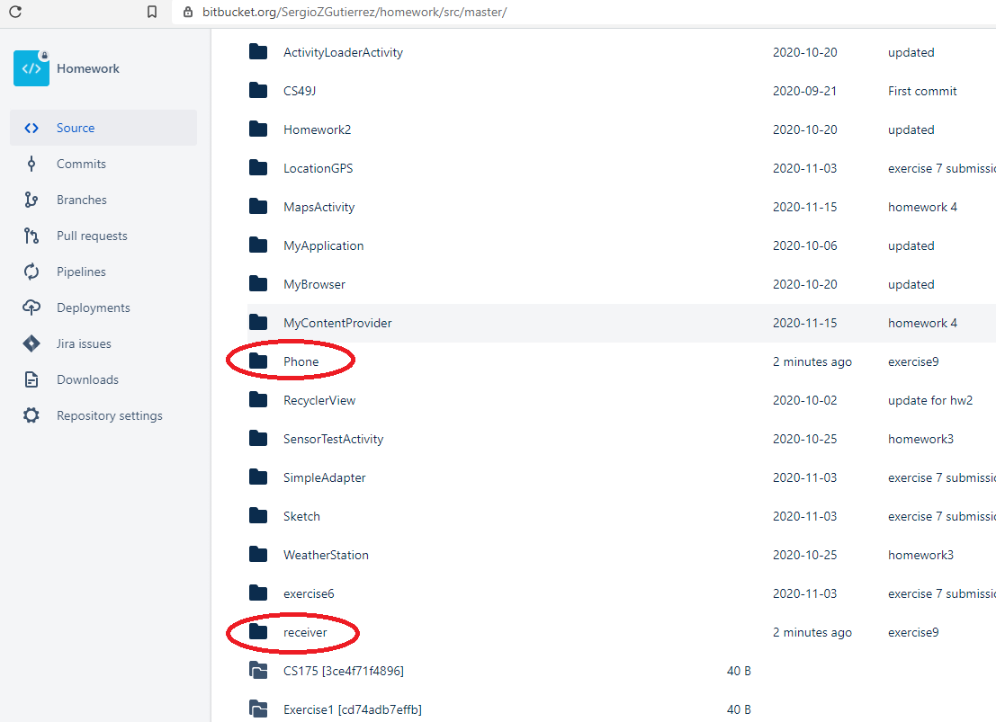

Exercise 9, part 1:

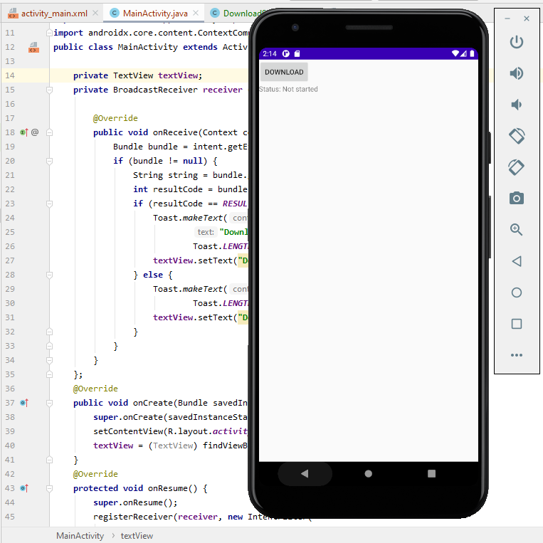

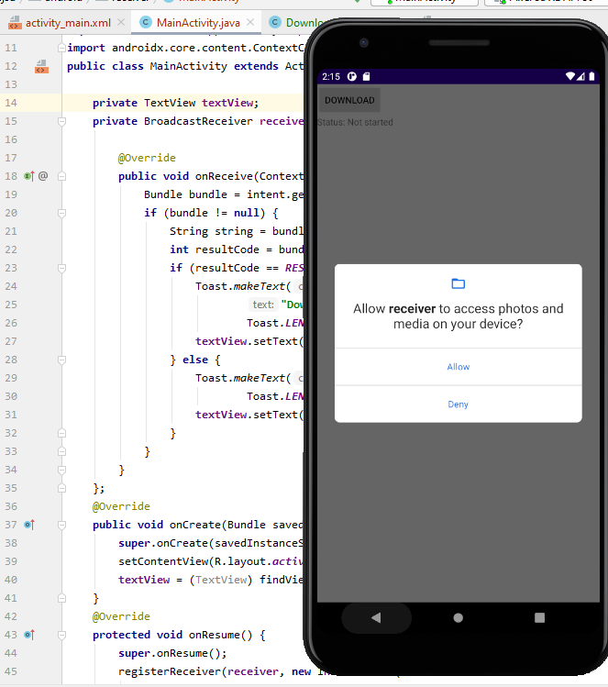

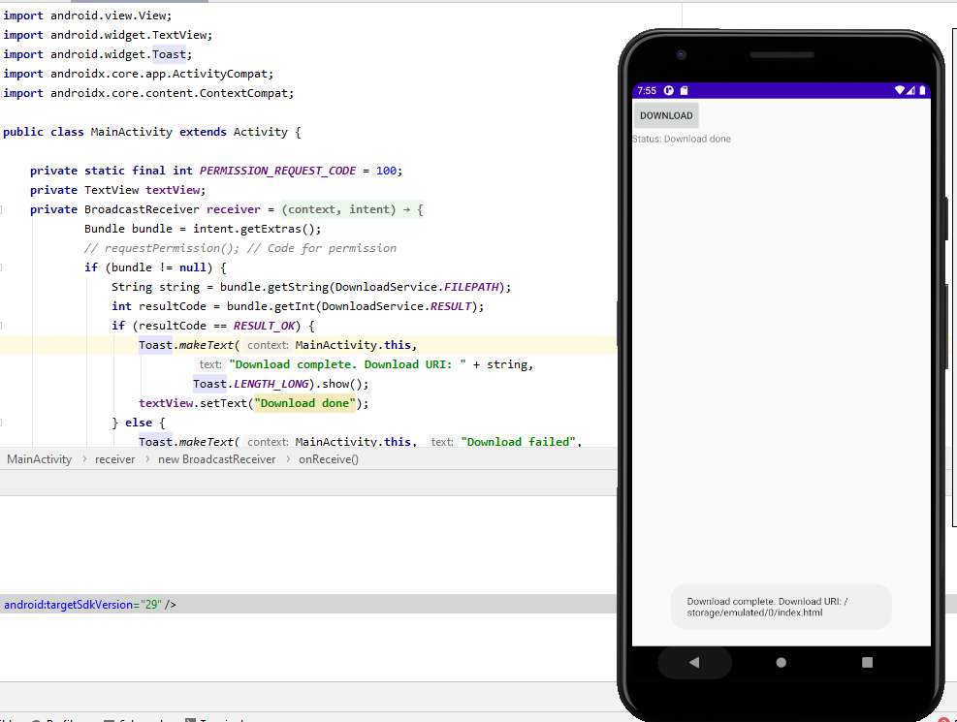

Exercise 9, part 2:

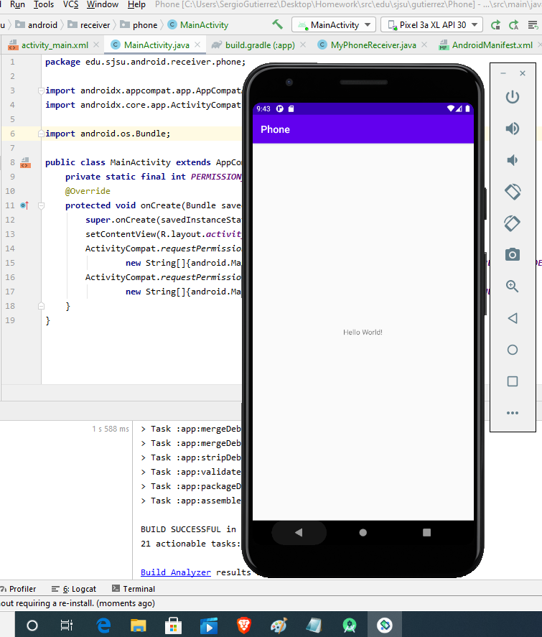

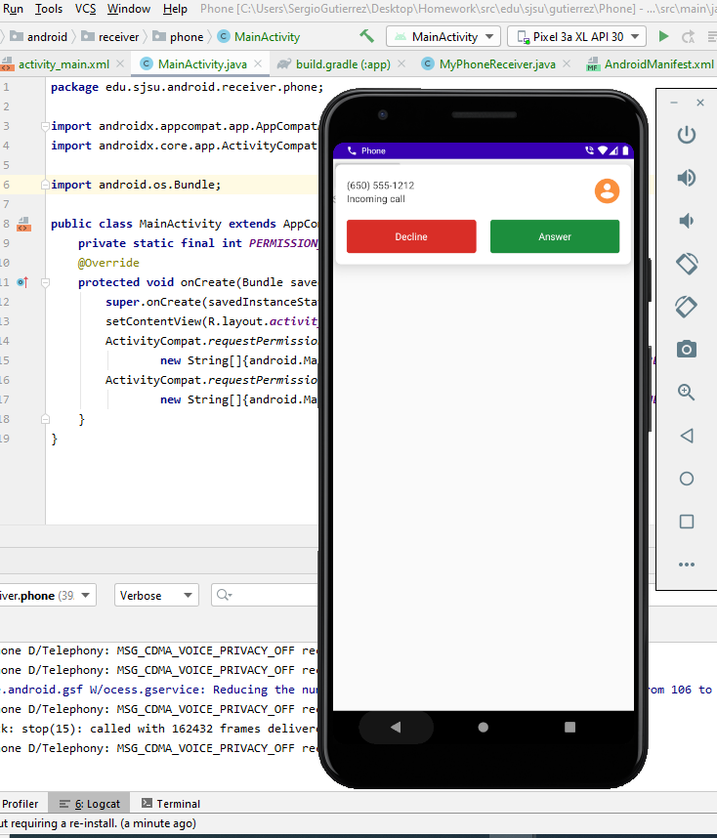

The exact pathway of where the .java files are located in my repository are:

<https://bitbucket.org/SergioZGutierrez/homework/src/master/receiver/app/src/main/java/edu/sjsu/android/receiver/>

and

<https://bitbucket.org/SergioZGutierrez/homework/src/master/Phone/app/src/main/java/edu/sjsu/android/receiver/phone/>